**Conceptual architecture of the distributed system**

The application is designed as a distributed system, playing the role of an extension for the previously assigned task, where an Online Medication Platform was built for Doctors, Patients and Caregivers, where doctors could create medication plans for patients with existing or custom medications, caregivers could see their assigned patients and patients could see details about themselves and their medical record. As an extension to the previous application, which will be referred in this case as the Consumer, the current application, referred to as the Producer, will extract the activities from an .txt (text) file and send them to a Queue, after being parsed in a JSON format as described in the requirements. Then, we need to run the Consumer application, which will take the messages (i.e. activities) from the queue and display the anomalies based on the rules R1-R3 mentioned in the assignment requirements. The additional features that arrive together with this assignment is the fact, that each patient has an intelligent pill dispenser that can be programmed with the plan defined by the doctor. The pill dispenser will alert the patient when a medication has to be taken and when a patient did not take the medication in the corresponding time interval. The pill dispenser can communicate with the server using RPC. For this implementation, I chose to use the JSON-RPC framework, implementing both parts, server and client, using a RabbitMQ implementation approach. This made things simple, facilitating also the success of the deployment process.

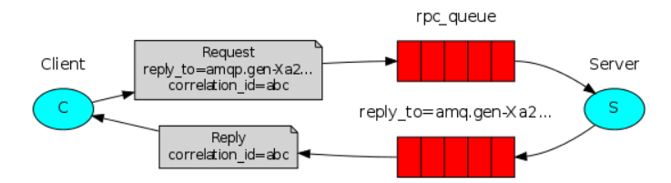

*Fig 1. Additional to the conceptual architecture of the distributed system done for the previous assignment*

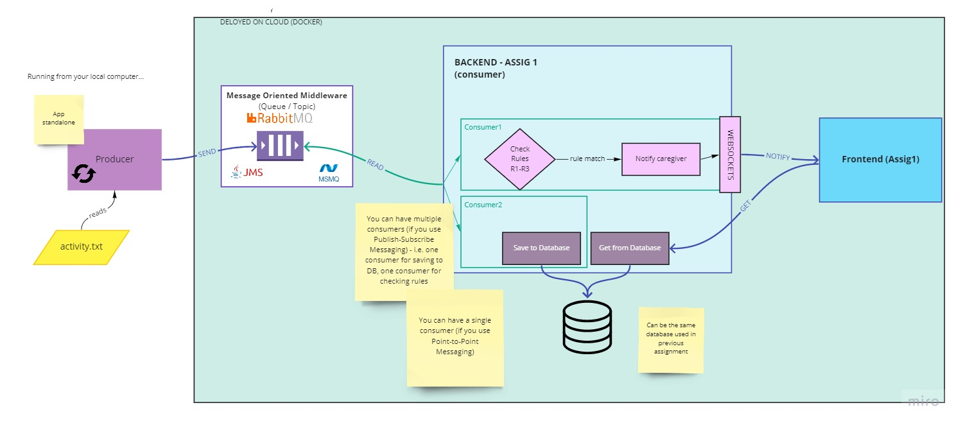

*Fig 2. The conceptual architecture of the distributed system from previous assignment*

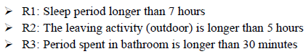

*Fig 3. The three rules denoting anomalies in patient behavior*

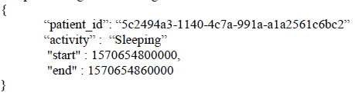

*Fig 4. The JSON format of the activity structure*

1. the pill dispenser can download the medication plan from the server
2. the pill dispenser displays when at the current time a medication has to be taken, and a button for “Medication taken” is displayed
3. if the button is pressed within the given time interval, the medication is marked as taken and the corresponding message is sent to the server; if the button is not pressed within the given time interval, the medication is marked as not taken and the corresponding message is sent to the server.

**Database design**

Data inside the database is necessary in order to keep track of information regarding patients, caregivers and doctors, as well as medications, side effects and medication plans designed for each user individually. Also, login information needs to be stored inside the database in order for the different users of the application to be able to retrieve contents about themselves or about other people or objects they are allowed to see or use. In the following diagram we have 11 tables, keeping data about patients and their medication plans, medication that may or may not be part of medication plans, caregivers that can take care of patients by viewing information about them and doctors that can manage data about caregivers, patients, medications and medication plans. In addition to the database from the previous assignment, we added 2 more tables, namely Activity and Activity_Of, in the same manner we included last time the tables Caregiver and Care_Of, to simulate a Many-to-Many relationship between the 2 table entities (Caregiver with Patient, last time and Patient with Activity, this time). The addition to the previous assignment comes to the fact that each Medication making part of a Medication Plan has a Start and End date for which it is prescribed. This has been done by adding to more columns for the Medication Plan List table.

**UML deployment diagram**

The deployment diagram keeps its structure from last time, the only difference lies in the fact that for this assignment the deployment was done only for the server-side of the application, which was done using Java Spring. The client side was developed using Java Swing. Since the Java Swing application was not deployed, I attached some images of how it looks and what it does. This shows how the application responds to taking no medication, waiting for a predefined time to get his medication plan and taking a prescribed medication from his current plan.

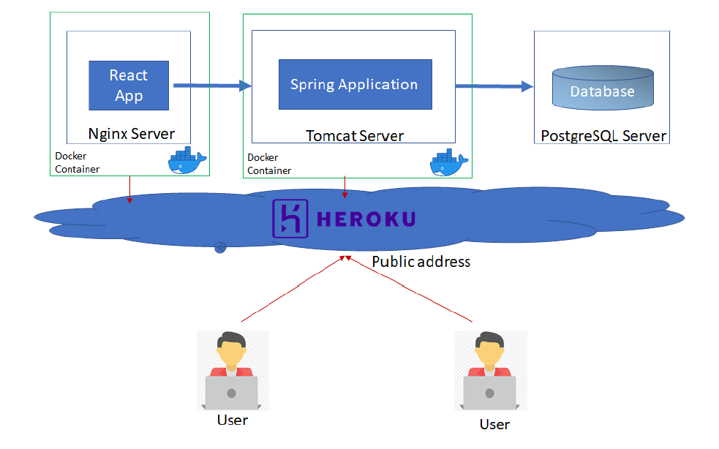

**Build and execution considerations**

When running for the first time the application, the user needs to have an IDE installed, that can compile and run Java Spring related tasks, a database server in order for the data to be stored, Apache Tomcat and an IDE with React development support. In my implementation, I chose to use IntelliJ IDEA for the backend development, storing the data in a PostgreSQL database and using Visual Studio Code for the frontend development part using React components. For the application to be successfully executed, the project needs to have a Maven related structure, because of the connections and dependencies between IDE and database. The backend (executed from IntelliJ IDEA) needs to run first by executing the **SHIFT + F10** command. After the server has started, the frontend part of the application can be run, by opening a terminal inside Visual Studio Code and executing the command **npm start**. If everything is successful, a new tab inside your default browser will be opened with the link [*http://localhost:3000*](http://localhost:3000). By clicking the Login button in the top right corner of the recently opened webpage, the user will be redirected to the login page located under link [*http://localhost:3000/login*](http://localhost:3000/login)where he will be prompted to enter his login credentials, afterwards being redirected to a profile page, where they can view information about themselves. Depending on their role, they may be able to view details about themselves, meaning medication plans, if they are patients, the list of patients they care of ([*http://localhost:3000/patient*](http://localhost:3000/patient)), if they are caregivers or the list of caregivers they manage ([*http://localhost:3000/caregiver*](http://localhost:3000/caregiver)), together with all the information previously presented, if they are doctors. If a user will try to enter a webpage he is restricted to access, he will be prompted to an error page, saying that the page he is looking for does not exist. Also, the user will stay logged in only for a certain time period. The application can be stopped, by executing the **CTRL + C** in the Visual Studio Code terminal, for stopping the backend and by executing the **CTRL+ F2** inside IntelliJ IDEA. In addition to the considerations from last time, the first application which needs to be run is called SensorSimulator, such that the messages will be sent to the Queue. For the Queue related part of the project, I used RabbitMQ which was later deployed to CloudAMQP platform. In addition to the last assignment, when a caregiver will login and view his profile, a notification will pop up related to the anomalies of the patient it takes care of. These can also be viewed in the Console logs of the browser. After that, the messages will be consumed and inserted into the database. I attached some pictures of how the website looks like.

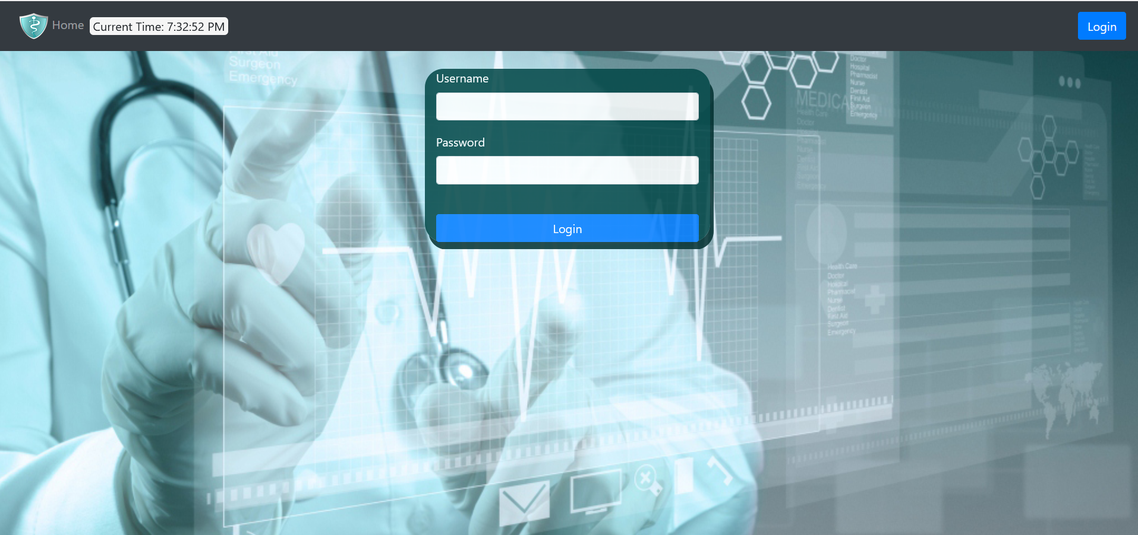

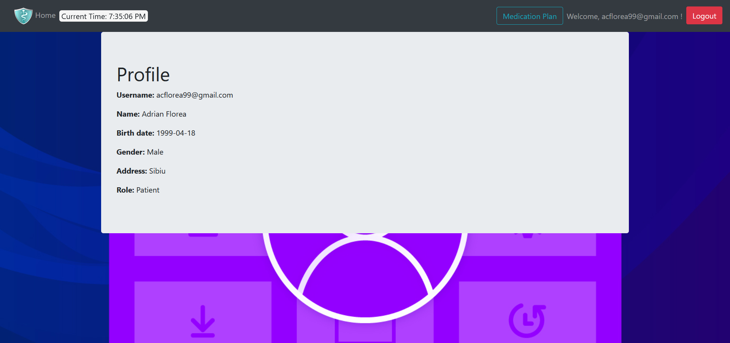

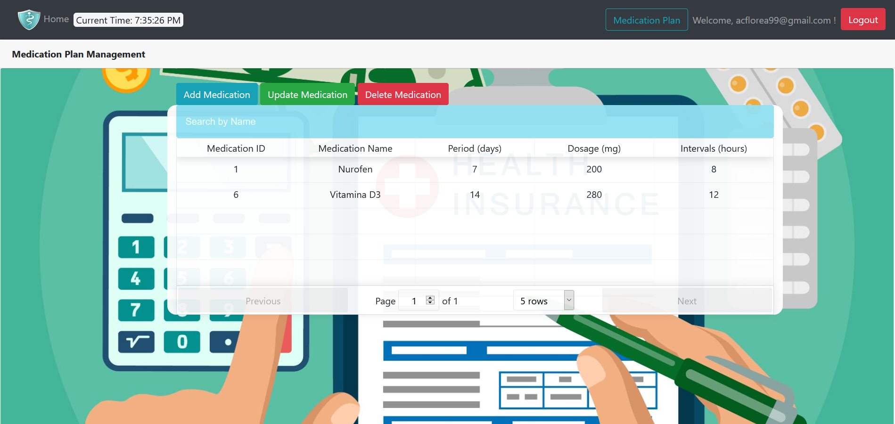

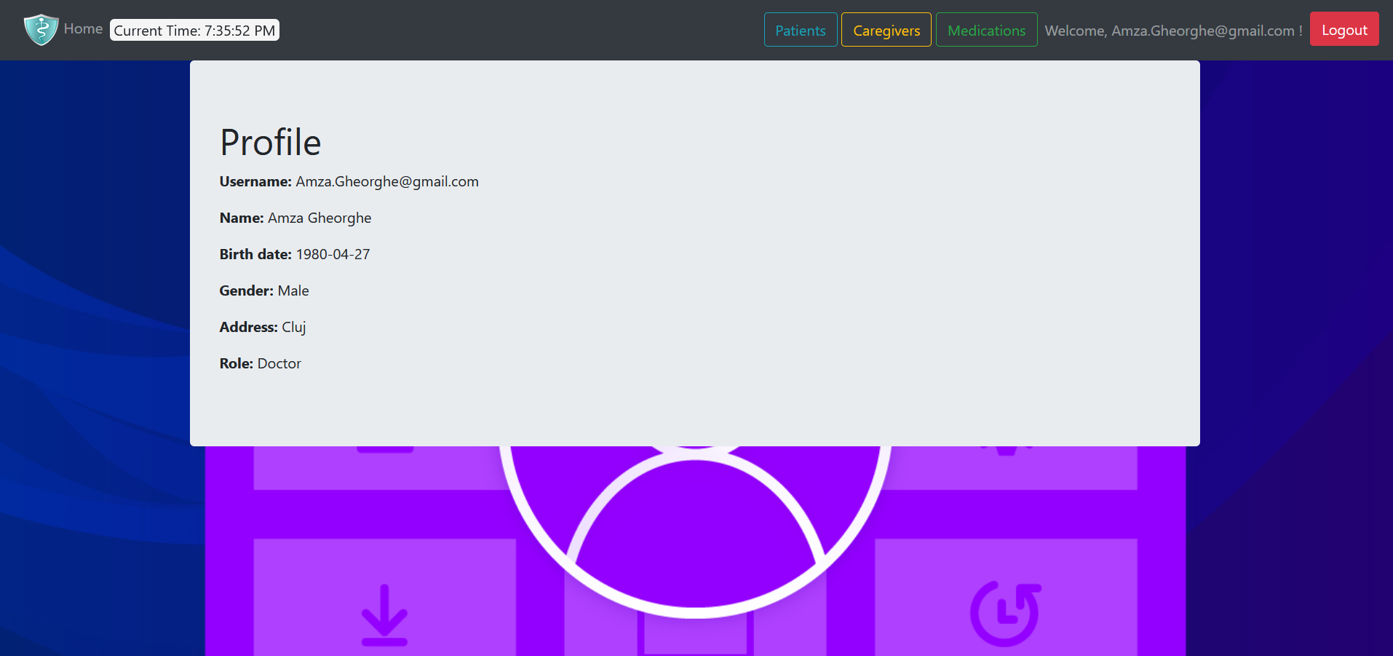

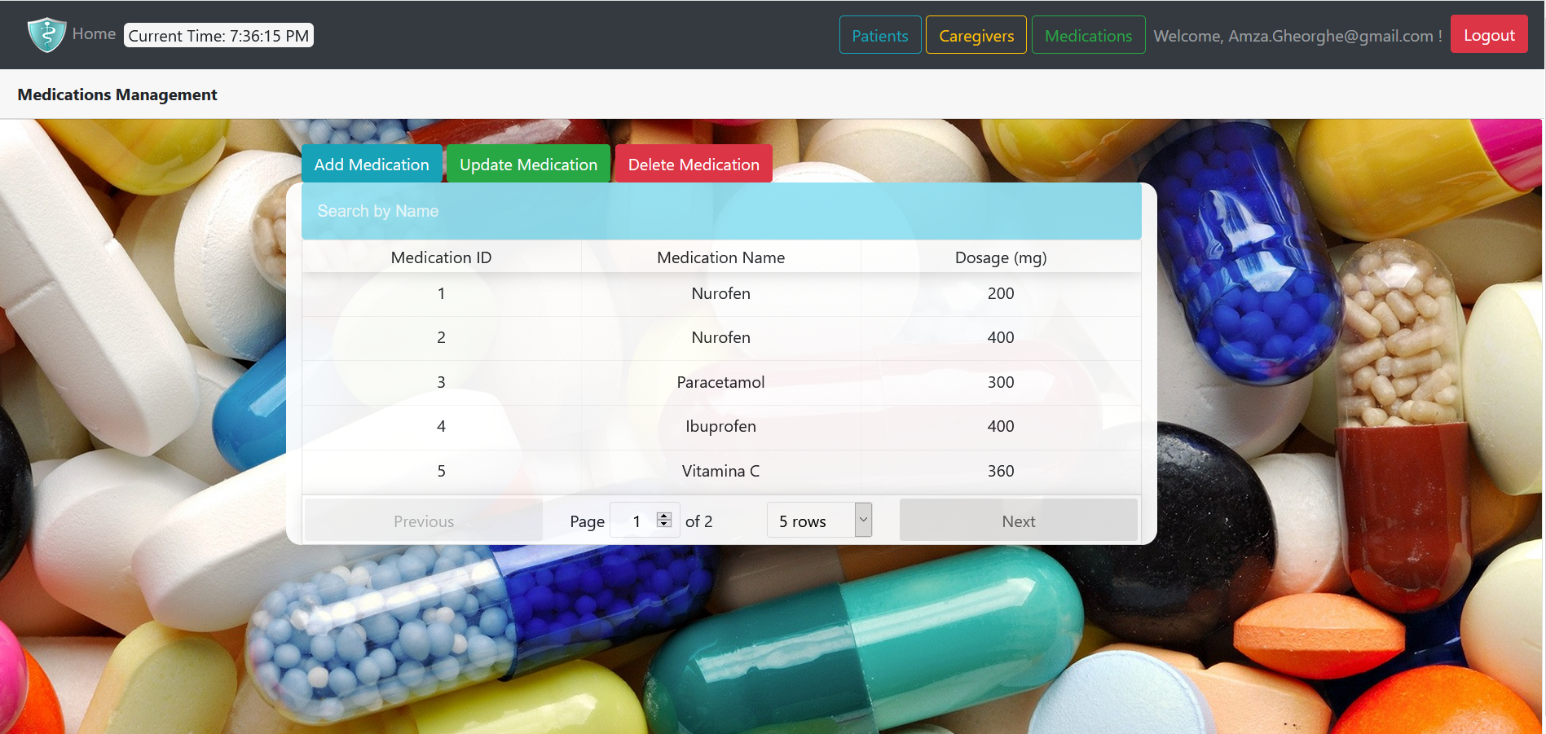

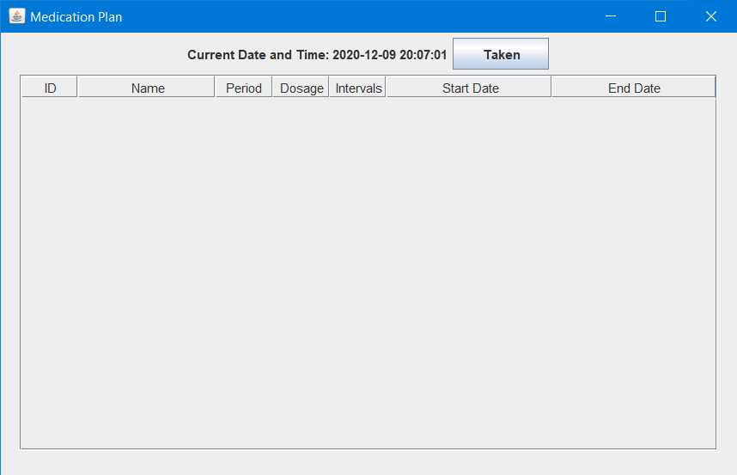

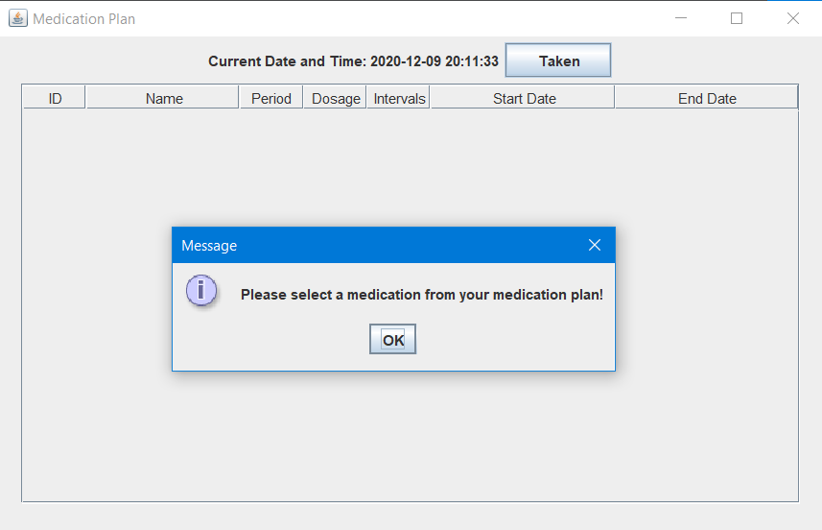

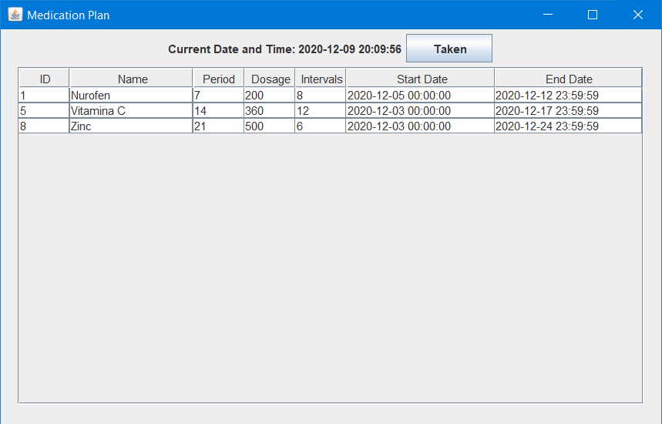

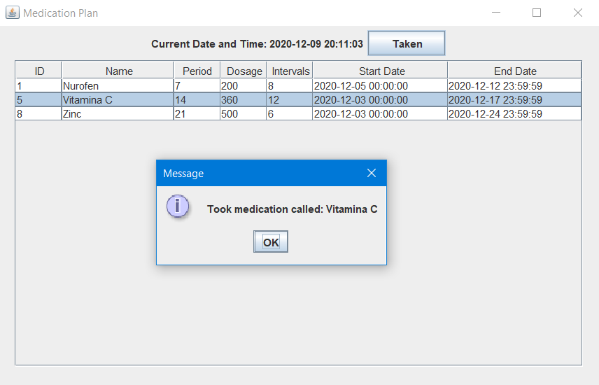

**Bibliography**

[1] <https://www.jmfurlott.com/handling-user-session-react-context/>

[2] <https://codesandbox.io/s/389o3qyoq5?file=/src/index.tsx>

[3] <https://www.baeldung.com/jpa-many-to-many>

[4] <https://gitlab.com/ds_20201/spring-demo>

[5] <https://bezkoder.com/react-jwt-auth/>

[6] <https://gitlab.com/ds_20201/react-demo>

[7] <https://www.geeksforgeeks.org/how-to-create-a-rest-api-using-java-spring-boot/>

[8] <https://www.freecodecamp.org/news/how-to-setup-jwt-authorization-and-authentication-in-spring/>

[9] <https://bezkoder.com/spring-boot-jwt-mysql-spring-security-architecture/>

[10] <https://www.javainuse.com/spring/boot-jwt>

[11] <https://www.rabbitmq.com/getstarted.html>

[12] <https://www.cloudamqp.com/blog/2015-05-18-part1-rabbitmq-for-beginners-what-is-rabbitmq.html>

[13] <https://www.baeldung.com/rabbitmq>

[14] <https://github.com/weibeld/JSON-RPC-Server-Heroku>

[15] <https://github.com/weibeld/JSON-RPC-Client-Heroku>

[16] <https://www.rabbitmq.com/tutorials/tutorial-six-spring-amqp.html>

[17] <https://github.com/rabbitmq/rabbitmq-tutorials/tree/master/spring-amqp>

[18] <https://github.com/briandilley/jsonrpc4j?fbclid=IwAR1XGRpxmhGsVGFptLBS8n1LWT5Xzzu6fqy1lxaGqgndmXO7IFtrd9Rd4JU>

[19]<https://github.com/arteam/simple-json-rpc?fbclid=IwAR135iJhO38LU9Mo50veWohe5TPAAmGc8lkZIZzSx_bb04Y9JIqPzwukci8>